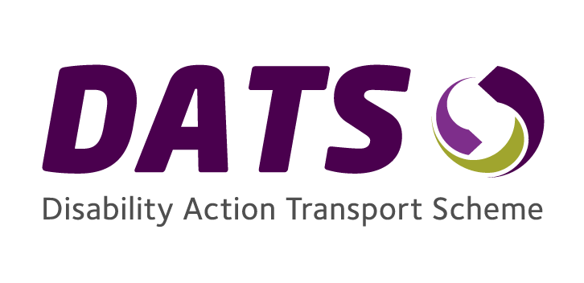
Transport Membership Application Form (WEBSITE)

This form is available in a range of alternative formats.
If you are not sure if you live within one of the Disability Action Transport Scheme areas, please contact us on the details at the end of this document.

Section1: Personal Details

Title: Mr Mrs Miss Ms Other

Forename(s): ______________________
Surname: ______________________
Address: ______________________
______________________
______________________
______________________
______________________
Town/City: ______________________
Postcode: ______________________

Telephone No.: ______________________

Mobile No.: ______________________

Email address: ______________________

Date of Birth: ______________________

Section 2: Emergency Contact Details

This section is optional but it would help us if you nominated a relative, friend or neighbour who maybe be contacted on your behalf in case of an emergency.

Name: ___________________
Telephone No: ___________________
Mobile No: ___________________
Relationship to applicant: _________________________

Section 3: Tell Us About Yourself

The next section is being used so that we can tell the driver of the Disability Action Transport Scheme vehicle what additional assistance you may require.

Please tick the boxes below which apply to you (otherwise leave blank).

I use a wheelchair
My wheelchair is:
Electric/Powered
Manual
I require assistance getting from my home to the vehicle.
I have a medical certificate exempting me from wearing a seatbelt.
I enclose a photocopy of my certificate.
I require an essential companion(s), such as my spouse, to travel with me

If you have ticked the above question, please state how many (maximum of 2):

I have dependant children who may travel with me.
If you have ticked the above question, please state how many:

I have a guide / assistance dog.
I have a learning disability.
I have a hearing difficulty
I have a visual disability.
I have mental health condition.
I have a communication disability.
Other necessary information.

I require written information in another format
(please tell us what format you require below).

_____________________________________________________

Section 4: Eligible Membership Criteria

This section is to confirm that you are eligible to use Disability Action Transport Scheme
Please tick one of the following boxes:

- Registered Blind

I am registered as blind.

If you have ticked this box, you must provide a photocopy of a letter from your local Health Trust confirming you are registered blind.

- Age Qualification

I am 80 or over.

If you have ticked this box you must provide a photocopy of your birth certificate, medical card, Electoral ID Card, passport or valid UK driving licence.

- Disability Living Allowance – Mobility Component or Enhanced Rate Mobility Component of Personal Independence Payment (PIP)

I am in receipt of the higher rate of the Mobility Component of Disability Living Allowance / or the Enhanced Rate Mobility Component of Personal Independence Payment (PIP).

If you have ticked this box you must provide a copy of your most recent letter from the Social Security Agency / Department of Communities to confirm that you are receipt of this benefit.

If you do not have this please contact us.

- Disability Living Allowance – Care Component or Enhanced Rate of the Daily Living Component of Personal Independence Payment (PIP

I am in receipt of the higher rate of the Care Component of Disability Living Allowance or the Enhanced Rate of the Daily Living Component of Personal Independence Payment (PIP)

If you have ticked this box you must provide a copy of your most recent letter from the Social Security Agency to confirm that you are receipt of this benefit.
If you do not have this please contact us.

- Attendance Allowance – Care Component

I am in receipt of the higher rate of the Care Component of Attendance Allowance

If you have ticked this box you must provide a copy of your most recent letter from the Social Security Agency to confirm that you are receipt of this benefit.
If you do not have this please contact us.

Section 5: Additional Information

Please note if you do not sign this form and consent to the Data Protection Statement below, Disability Action will be unable to process your application.

Data Protection Statement

In order to comply with the Data Protection Act 1998, the personal information you have provided in your membership application form will be held by Disability Action and its agents for the purposes of managing the Disability Action Transport Scheme.

Disability Action will use non-personal statistical data to analyse and plan for the service.

If you are not happy with this data protection statement contact the Transport Manager at Disability Action

Declaration

I confirm that the information given is correct.

Signed ___________________________ Date ______________

If you are signing on behalf of the applicant, please print your name and relationship to them e.g. Friend/Relative

What do I do now?

- Check that you have completed the form and ensure that it is signed and dated.

- Make sure you have enclosed copies (do not send originals as we cannot return these) of letters or certificates that are required for proof of benefit, age or registered blind.

- If you are exempt from wearing a seatbelt, ensure you have enclosed a copy of your exemption certificate.

- Return the completed application form using the contact details overleaf. Please allow 28 days for us to process your application.

Section 6: Equality Information

Disability Action is keen to collect information on the members of Disability Action Transport Scheme for equality monitoring and statistical purposes. As a result, we are asking you to answer the following questions. However you do not have to answer them.

- What s your religion
Protestant
Catholic
Other religion
No religious belief

- What racial group do you belong to?
White Other

- What is your status?
Single
Married
Civil Partnership
Separated
Divorced
Widowed

- What gender are you
Male Female

If you require any additional information please contact us on the details below.

Disability Action Transport Scheme
Portside Business Park,
189 Airport Road West, Belfast
BT3 9ED.

Telephone: 028 9029 7870
Email: transport@disabilityaction.org
Web: www.disabilityaction.org/transport

